Rayolite Installation Guide

Application Instructions –Adhesive Tar Pad for Road Markers

Overview

Adhesive Tar Pads are a proven adhesive system for securing raised pavement markers and other bonded applications across Australian roads. Designed with installers in mind, Adhesive Tar Pads delivers confidence in performance, safety, and sustainability. The pre-formed pads enable faster, safer installs with consistent quality and a smaller environmental footprint. They cut downtime, protecting workers, and providing stronger, longer-lasting bonds than epoxy, bitumen, or hot-pour systems.

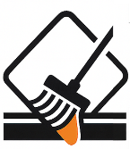
1. Surface Preparation
- Ensure the road surface (asphalt, concrete, stone, or brick) is clean, dry, and free from dust, oil, or debris.
- If moisture is present, lightly heat the surface with a propane burner to dry it — do not overheat.
- On concrete or stone, apply a suitable primer over the bonding area and allow it to cure before continuing.
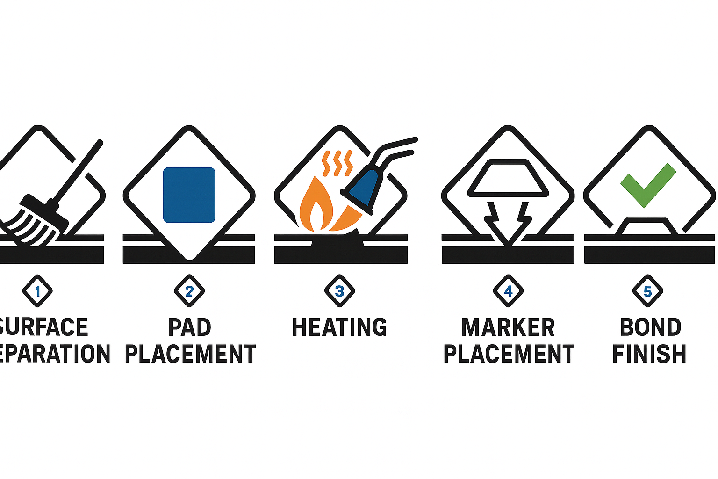
2. Pad Placement
- Position the Bundy Tar pad in the desired location.
- Confirm alignment before heating.

3. Heating
- Apply steady, even heat with a propane burner until the Bundy Tar pad is molten and bubbling.
- Ensure adhesive flow leaves a 7.5 mm (¾ cm) margin around the marker footprint.
4. Marker Placement
- Immediately set the marker on the molten Bundy Tar.
- Apply firm, even pressure to seat the marker without forcing out adhesive.
5. Bonding & Finishing
- Allow the installation to cool naturally.
- The marker is traffic-ready once the adhesive has hardened.

Handling & Storage
- Store pads flat, dry, and under cover; avoid excess stacking.
- Supplied in convenient, pre-formed pads that fit most common marker bases.
- Handle with care in cold conditions (pads may be brittle).
- Observe the shelf life (12–24 months); discard degraded material.

Key Benefits

- Superior Bond Strength – Keeps markers in place even under heavy traffic and extreme impacts.
- All-Surface Versatility – Bonds reliably to asphalt, concrete, stone, and brick.
- Resilient Options – Super Bundy Tar stays flexible in high-stress zones, reducing marker loss.
- No Temperature Limits – Can be applied in cold or warm conditions with no minimum surface temperature.
- Retroreflective Safety – Contains glass beads for visibility even if a marker is dislodged.
- Environmentally Safer – Non-toxic, VOC-free, and free of heavy metals.
- Zero Waste Application – Pre-formed pads eliminate mixing, solvents, and on-site waste.

Why Adhesive Tar Pads Over Other Methods?

- No Mixing, No Mess Traditional epoxy systems require on-site mixing with precise ratios, creating waste and variability. They are pre-formed and consistent, just heat and bond, with no mixing and no wasted product.

- Faster Installation Hot-pour and bitumen methods need heating kettles or extended curing.
Bundy pads install quickly: heat until molten, set the marker, allow to cool. Traffic can resume within minutes.

- Safer for Workers Epoxies and solvent adhesives expose crews to hazardous fumes and skin sensitizers. Bundy pads are non-toxic, VOC-free, and heavy-metal-free. The only safety requirement is careful handling of the propane torch.

- Reliable Bond Strength Epoxy can be unreliable in wet or cold conditions, and bitumen can soften in high heat. Bundy pads create a thermoplastic bond that performs reliably across a wide range of road and climate conditions, ensuring markers stay firmly in place.

- Cleaner Job Sites Epoxy kits and bitumen pots create sticky waste and require clean-up.
Bundy pads are cut-to-size and pre-packaged, leaving no mixing residue or site waste.

- Consistent Quality Site-mixed products depend heavily on installer skill. Bundy pads deliver factory-controlled uniformity for reliable performance every time.

- Easier Maintenance With epoxy or bitumen, replacing a marker often means chiselling out hardened adhesive. With Bundy, simply apply a new pad over the old footprint and re-set the marker — a fast and simple repair.

- Environmentally Smarter Bitumen and solvent adhesives are petroleum-based and less sustainable. Bundy pads are non-toxic, solvent-free, and contain no heavy metals, making them the smarter choice for modern infrastructure.

Safety Guidelines for Bundy Tar Pad Installation

- Personal Protective Equipment (PPE): Always wear safety glasses, heat-resistant gloves, long sleeves, and high-visibility workwear.
- Propane Burner Safety:
  - Use only approved torches.
  - Keep the flame directed at the adhesive, not the operator or surroundings.
  - Be mindful of nearby flammable materials.
- Heat Hazards: The adhesive becomes molten and extremely hot. Avoid direct contact and allow adequate cooling time before touching or working near installed markers.
- Ventilation: Work in well-ventilated areas. Although Bundy contains no solvents or VOCs, combustion gases from propane burners must be safely dispersed.
- Worksite Safety:
  - Use proper traffic management controls to protect workers and road users.
  - Ensure stable footing when applying heat on uneven or sloped surfaces.
- Disposal: Offcuts or damaged pads can be disposed of with standard construction waste streams, as they contain no toxic materials.

Rayolite Pty Ltd
Address: 237-239 Berkeley Rd, Unanderra, NSW 2526
Postal: PO Box 1156, Unanderra, NSW 2526
Phone: (02) 4271 5056
Mobile: 0407 473 889 Greg
Mobile: 0468 871 319 Leesa
Email: sales@rayolite.com.au

The facts stated and the recommendations made are based upon data appraised in our own laboratories and our own research and that of others. Due to possible differences in specifications, application and interpretation of results, no guarantee can be made of these products and they are sold without warranty, express or implied in law or in fact upon the condition that the purchasers make they own test of the products or samples thereof to determine the suitability of the products for the purchasers intended use. Statements concerning the possible use of products or processes are not recommendations or permission to use the same in a manner that would infringe any patent or to practice as patented invention without a licence.

